* **GiT BASH**
* **Git: publish a project**

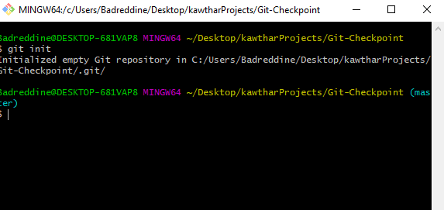

>> git init

* **Git: push**

>> git add .

>> git push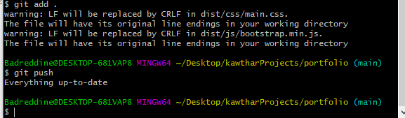

* **Git: pull**
* **Git: clone project**

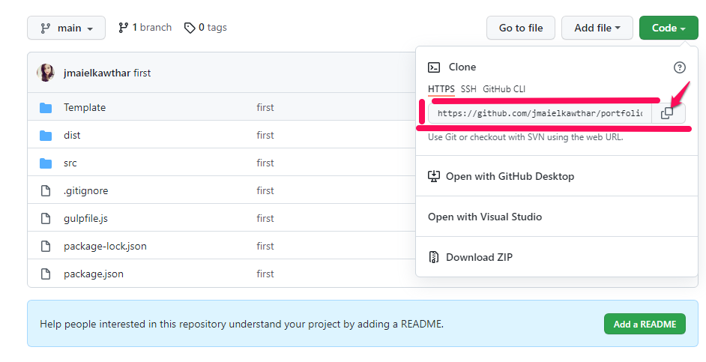

* **First click to get the URL of the desired project.**
* **Open git bash.**
* **Create a folder.**
* **Taper the following command:**

>>git clone <https://github.com/jmaielkawthar/portfolio.git>

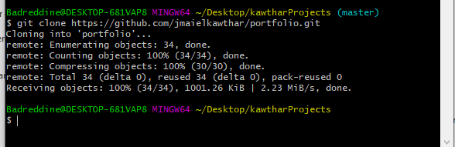

* **Git: fork project**

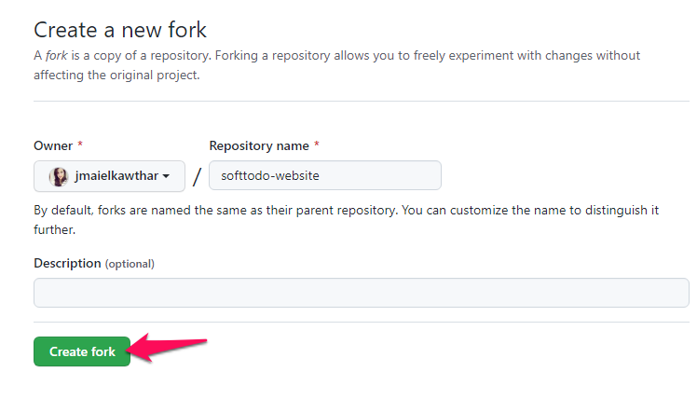

**Get the project you like in your GitHub by simple tools fork.**

* **Git remove specific fishier from git.**

>> git rm –checked file1.txt

* **Get histories:**

>> git log

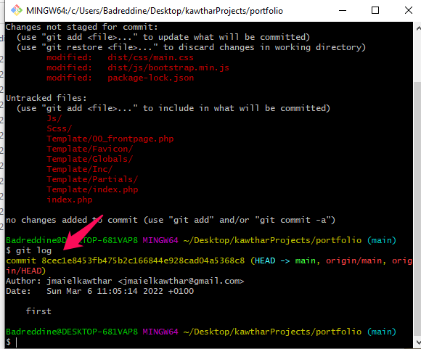

* **status of the project:**

>> git status

